**Case Study 1**

* Describe the dataset and any issues with it.

Missing value and mult-collinearity are being found in this dataset.

* Generate a minimum of 5 unique visualizations using the data and write a brief description of your observations.

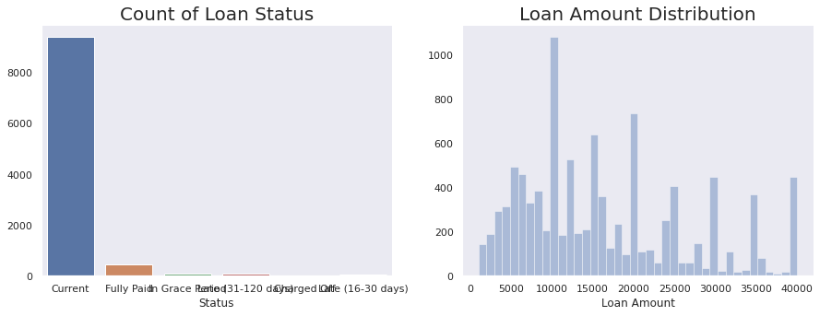

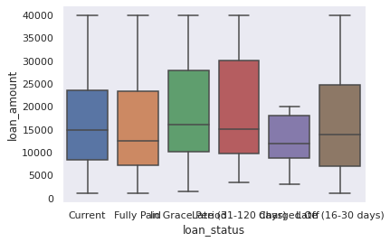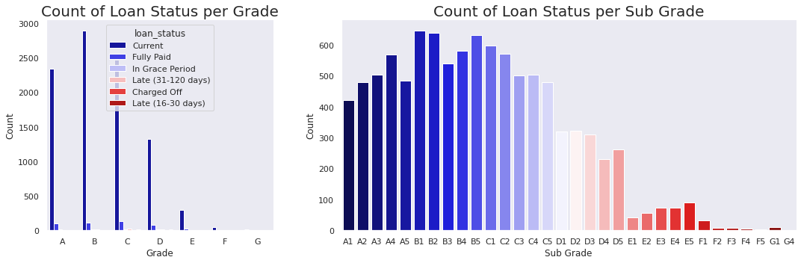

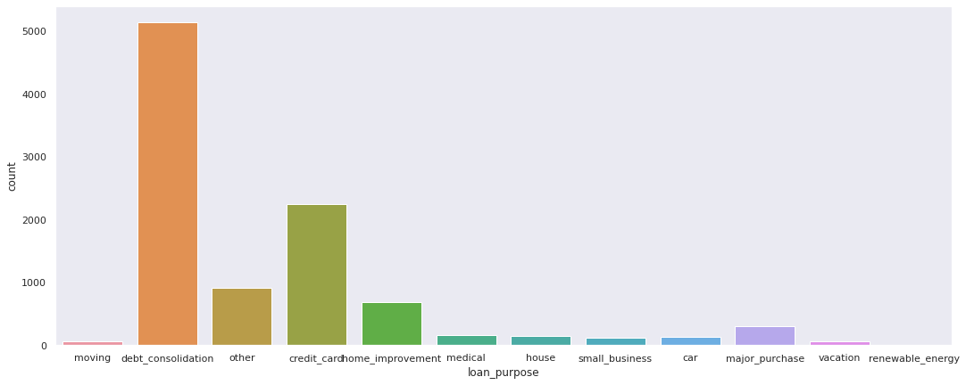

* Visualize the test results and propose enhancements to the model, what would you do if you had more time.

Logistic Regression

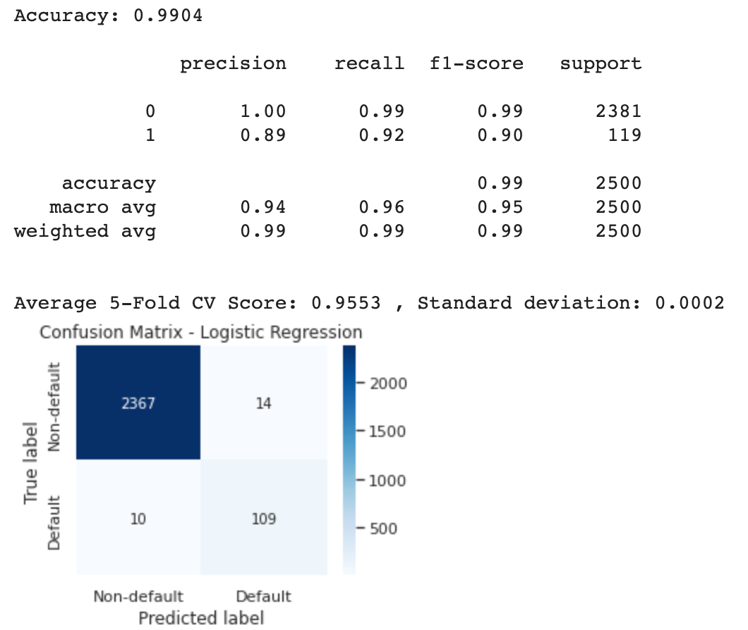

**Moving Forward**

* Feature scaling/normalization,wherecheckingthescaleofourvariablestoseeif there aren’t any features that are dominating the others.
* Class imbalance in the data
* Perform PCA analysis to determine if we can further reduce the number of variables used for other prediction models
* Apply oversampling technique ADASYN